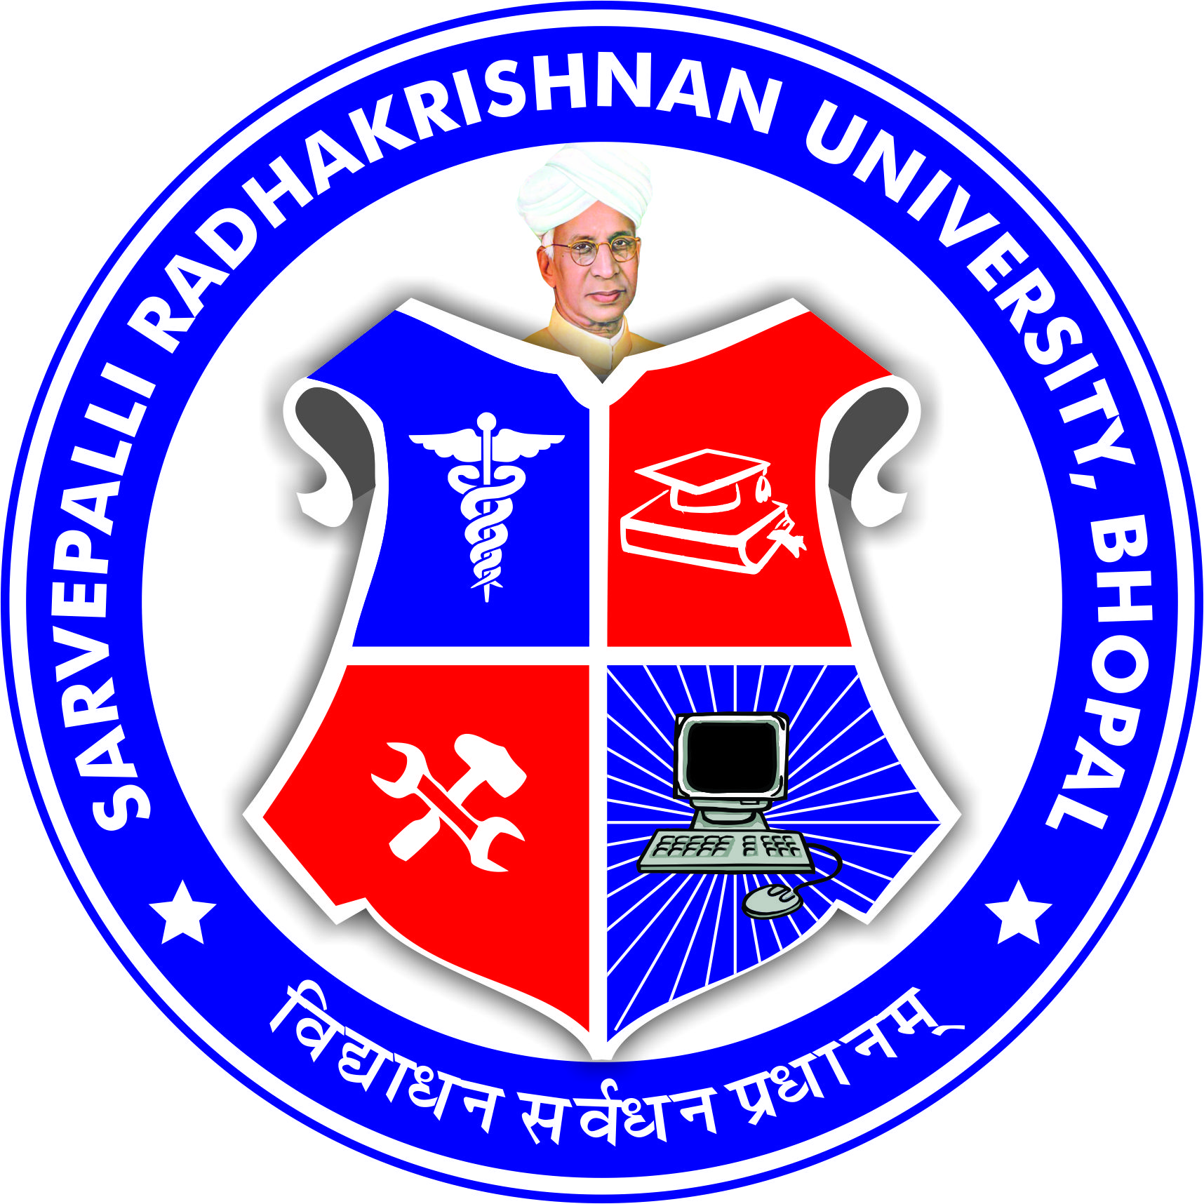
SARVEPALLI RADHAKRISHNAN UNIVERSITY
NH 12,RKDF IST CAMPUS, HOSHANGABAD ROAD, MISROD, BHOPAL (M.P.)
¼Statutory University established by Govt. of M.P. under section 2(F½ of UGC act)
Website: www.srku.edu.in, E-mail: info@srku.edu.in/srkubhopal@gmail.com
Phone: 0755-4700981 Fax: 07554700981

OBC & Minority Grievance Committee Order
OBC & Minority Grievance committee of Sarvepalli Radhakrishnan University is here by reconstituted as below:
- Dr. Yogesh Sivhare Chairman` 9926225738
- Dr. Namrata Jain Member 9406567249
- Dr. Jyoti Yadav Member 7024091709
- Dr. Bharti Chaurasia Member 7974498943
- Ms. Palak Yadav Member 6267936144
- Dr. Ritesh Yadav Secretary 8269310228
- Mr. Abrar Ahmad Member 9575373669
- Mr. Santosh Negi Member 7566863834
- Mr. Mosin Mansuri Student Rep. 9174365292
(2nd Year B. Pharm)
- Mr. Sunit Yadav Student Rep. 8103752902
(1st Year M. Pharm)

Registrar

Note- Secretary of the committee shall be responsible for conducting meetings & maintaining minutes of meeting.

